**Feedback for adding featur disconected wallet in quest.somnia.network**

On the web *quest.somnia.network* currently there is no feature to disconnect the wallet, this makes the user less comfortable. Even though the wallet has been disconnected via the metamsak wallet, the wallet is still connected on the web *quest.somnia.network*

In image 1 the web is connected to the wallet metamask: 0xfa241344e2b16c9a5b323b7130753601d4b707ac

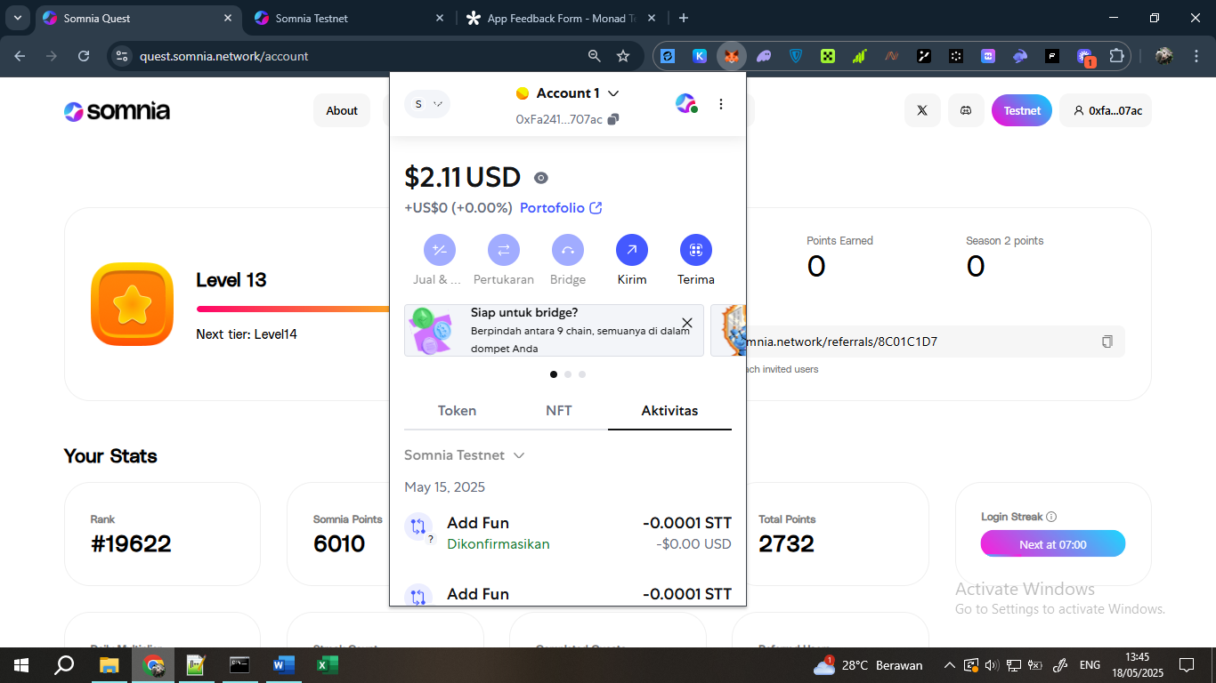

in image 2: Because there is no disconnect feature, the option is to disconnect via the Metamask wallet

First, open your Metamask wallet, then click on the logo on the right side

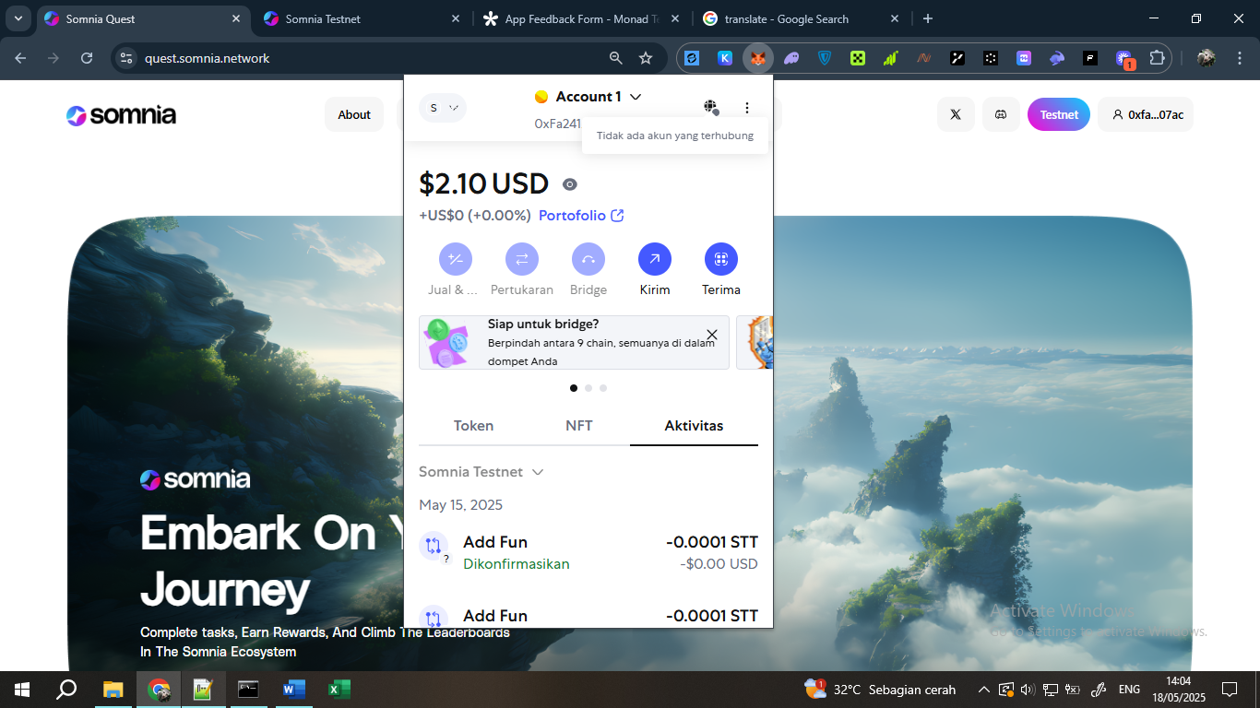

then click disconnect

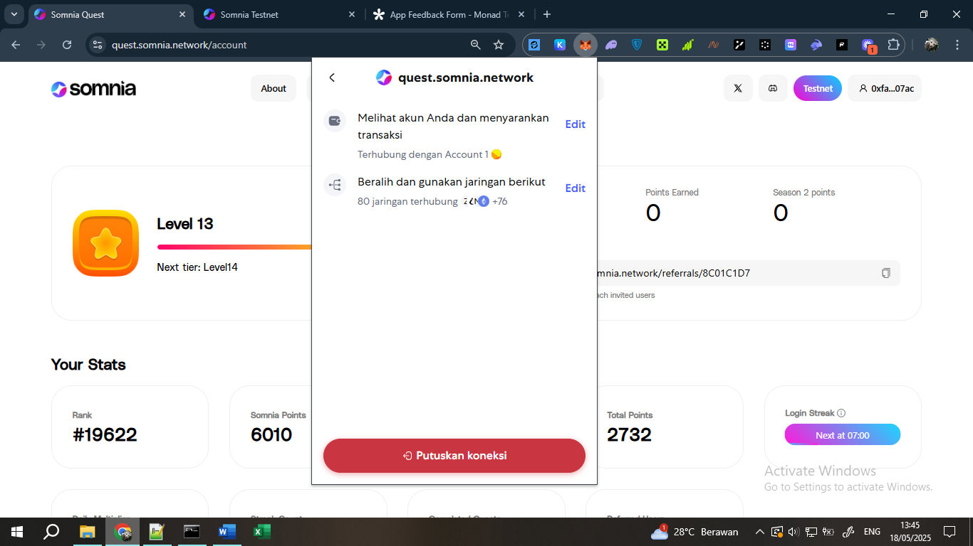

in the metamask wallet it says that the wallet connection to the *quest.somnia.network* web has been disconnected, but there is a bug in this section where when the *quest.somnia.network* web is refreshed. the wallet remains connected

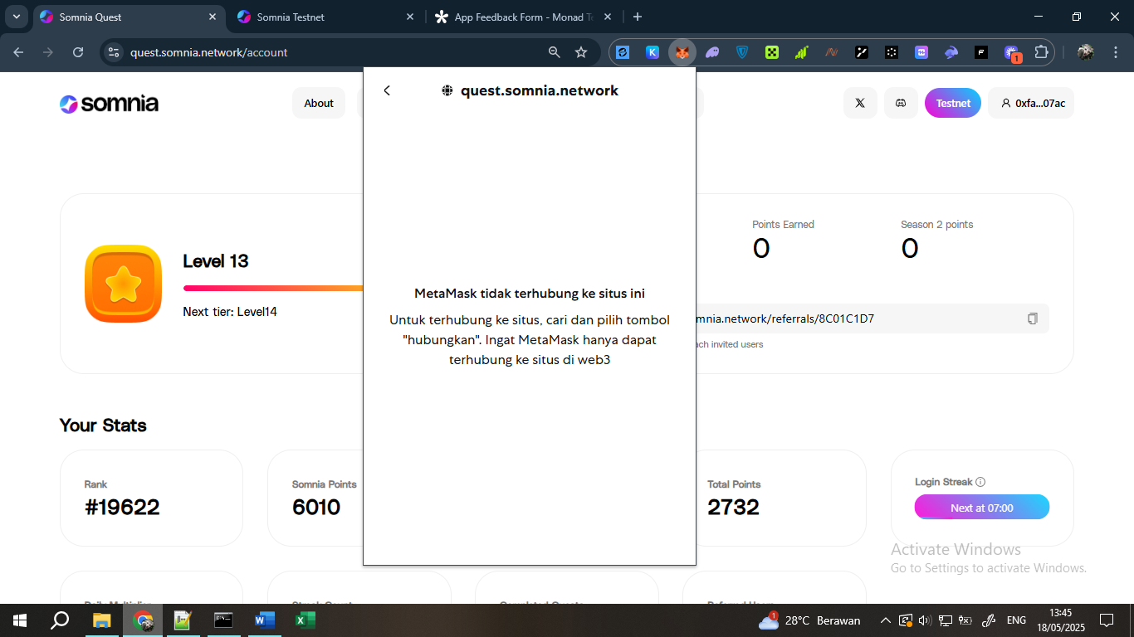

I suggest to the somnia developer team to add a disconnected feature to the *quest.somnia.network* web. This will make it easier for users to change wallets.

Link for video : https://www.loom.com/share/2cb9f5f805bf4f1fa5fe8017b333ad5d?sid=e2308fac-80cf-4b80-9089-4ff8ac36bcae